Vuyyala manesh cb.sc.u4cse24759

Stage – 1

1.Install prerequisites such as **gcc**, **make**, **readline**, **flex/lex**, **bison/yacc**  
For Debian-based linux distros:

sudo apt-get install libreadline-dev flex bison make gcc wget curl

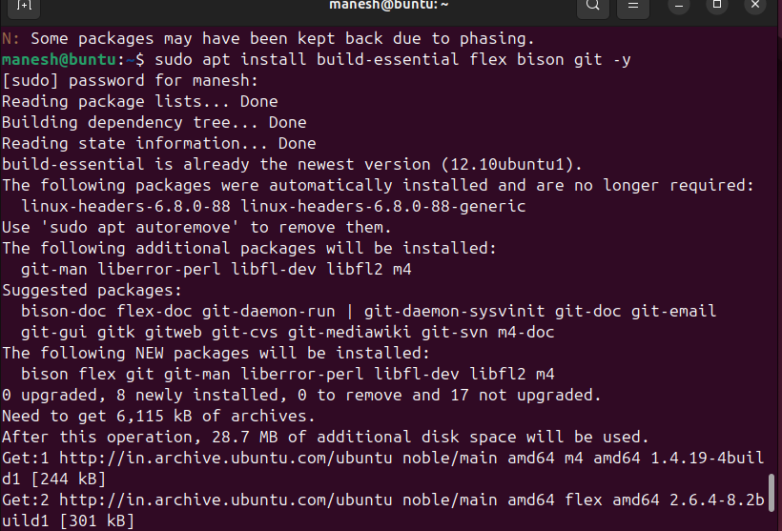

curl -sSf https://raw.githubusercontent.com/eXpOSNitc/expos-bootstrap/main/download.sh | sh

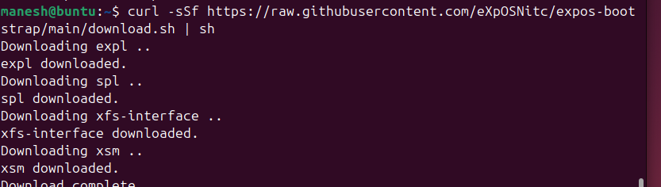

3.Change directory to myexpos directory.

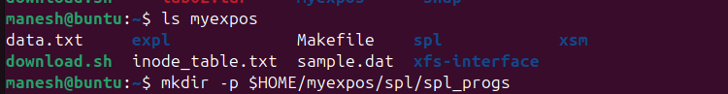

4. Make to build all the components.

Make

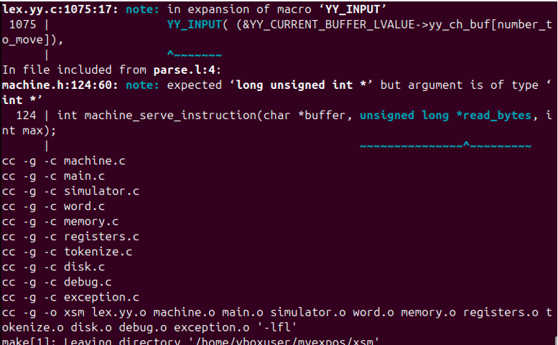

Stage –2

1.Run the XFS Interface  
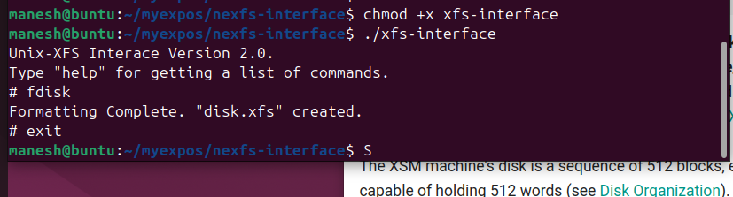

3. The [Disk Free List](https://exposnitc.github.io/os_design-files/disk_ds.html#disk_free_list) in XFS is a data structure which keeps track of used and unused blocks in the disk. An unused block is indicated by 0 and a used block is indicated by 1. Check the contents of the Disk Free List after formatting the disk. Use the **df** command to view the Disk Free List (stored in disk block number 2). The output will be as follows:

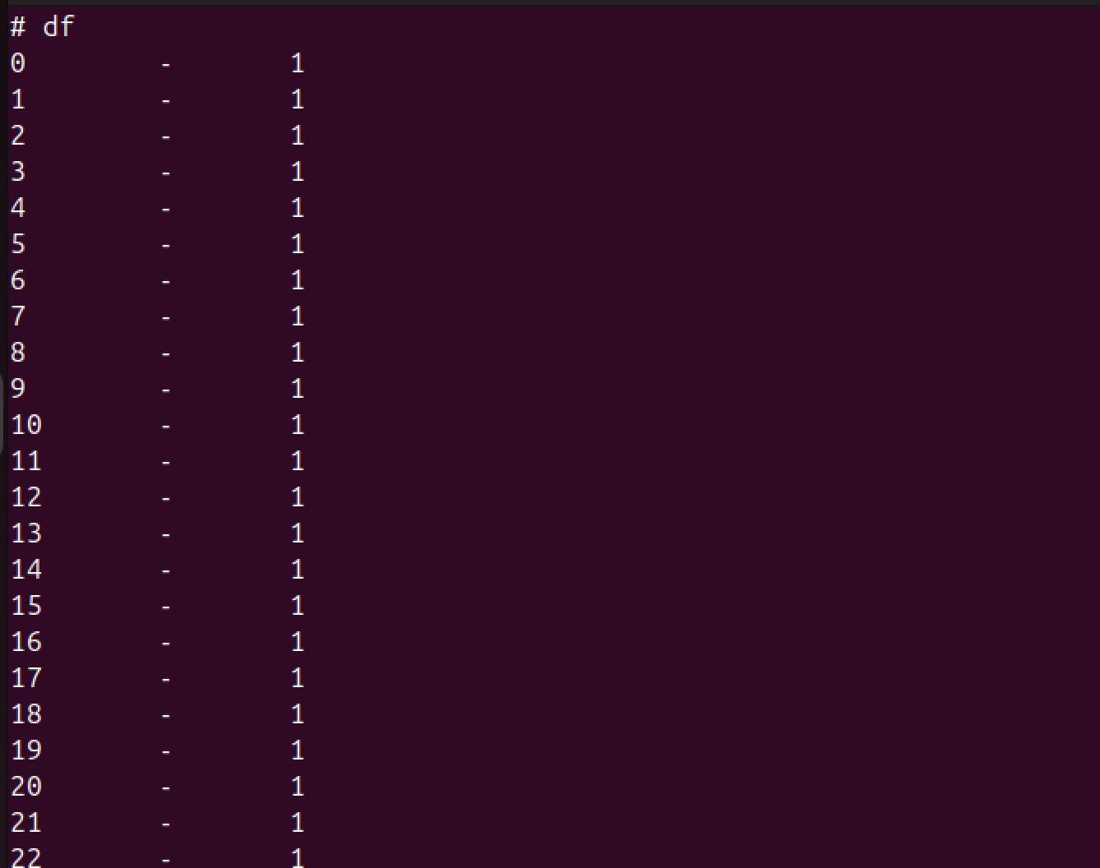

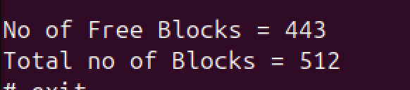4. Create a file in your UNIX machine with sample data. A sample data file is given below:

There is a place where the sidewalk ends  
And before the street begins,  
And there the grass grows soft and white,  
And there the sun burns crimson bright,  
And there the moon-bird rests from his flight  
To cool in the peppermint wind.

5. Load this data file ($HOME/myexpos/sample.dat) to the XFS disk from your UNIX machine. This can be done by the following commands:

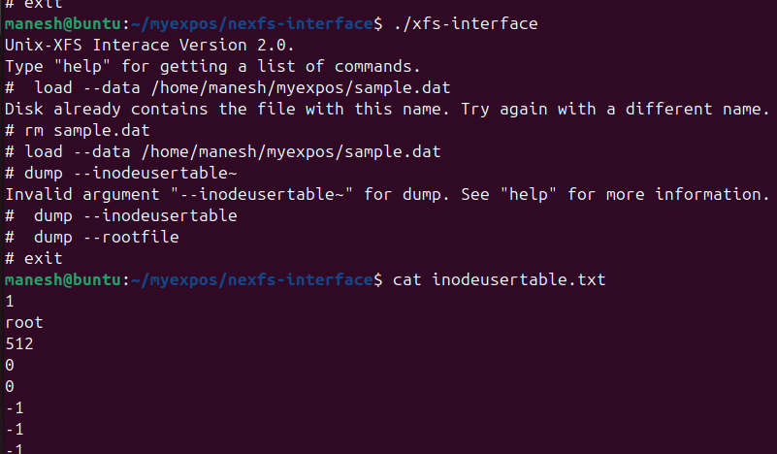

6. Find out the block numbers of the Data Blocks corresponding to the loaded file. Use the **copy** command to copy the *Inode Table*(Inode Table is stored in disk blocks 3 and 4) to a UNIX file (say $HOME/myexpos/inode_table.txt).

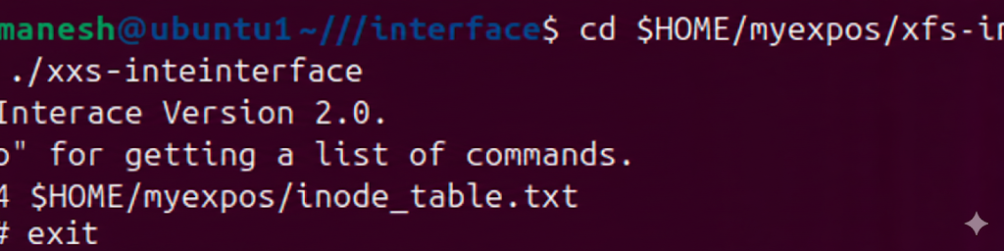

7.Now check the contents of the disk free list and verify that the entry for the 69th block is marked as used. This corresponds to the Data Block 1 of sample.dat

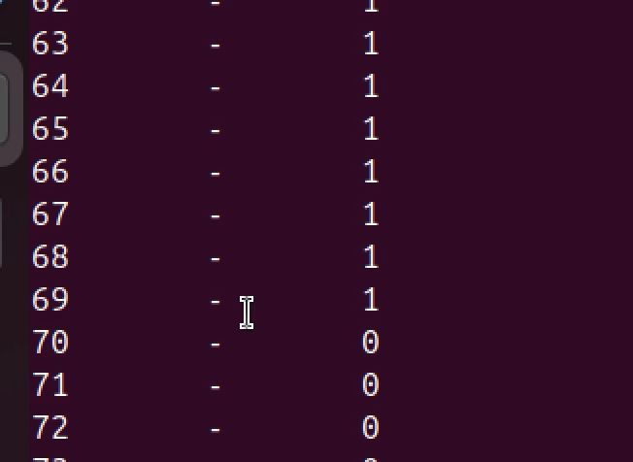

8. Copy the data blocks from the XFS disk and display it as a UNIX file $HOME/myexpos/data.txt.

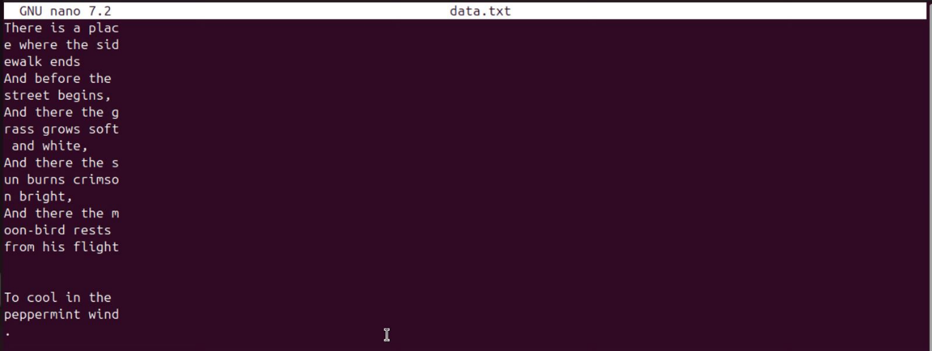

9. xfs-interface provides the [export](https://exposnitc.github.io/support_tools-files/xfs-interface.html#export) command to export files from the XSM machine to the UNIX machine in a single step. Export the file sample.dat to the UNIX file $HOME/myexpos/data.txt using *xfs-inteface* as shown below and verify that the contents are same as sample.dat.  
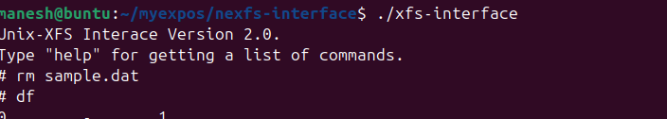

Assignment – 1

Copy the contents of Root File (from Block 5 of XFS disk) to a UNIX file $HOME/myexpos/root_file.txt and verify that an entry for sample.dat is made in it also.

copy 5 5 $HOME/myexpos/root_file.txt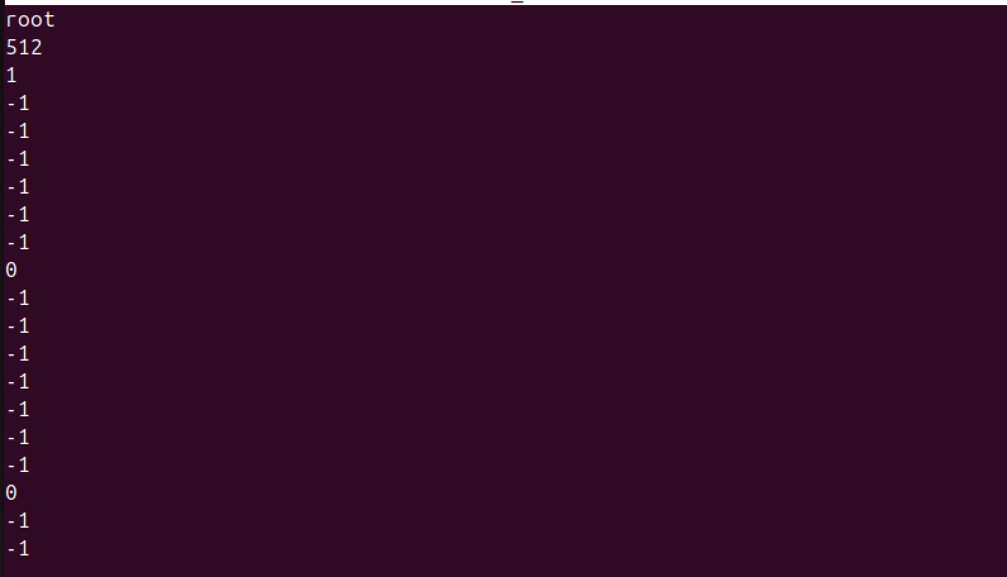Assignment 2

Delete the sample.dat from the XSM machine using xfs-interface and note the changes for the entries for this file in *inode table, root file and disk free list* .

STEPS

cd $HOME/myexpos/xfs-interface

./xfs-interface

delete sample.dat

./xfs-interface

copy 3 4 $HOME/myexpos/inode_table.txt

./xfs-interface

copy 5 5 $HOME/myexpos/root_file.txt

Now we should free the disk

./xfs-interface

df

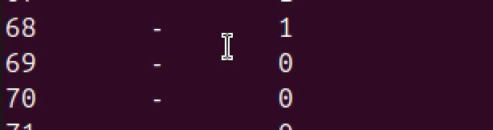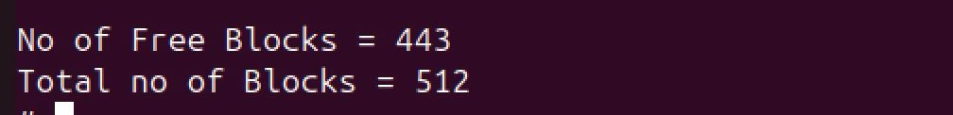

STAGE 3

1. Create the assembly program to print "HELLO_WORLD".  
The assembly code to print "HELLO_WORLD" :  
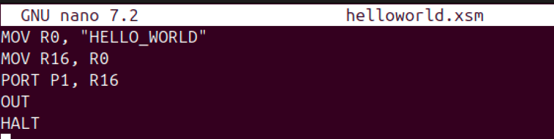

2. Load the file as OS Startup code to disk.xfs using XFS-Interface. Invoke the XFS interface and use the following command to load the OS Startup Code

cd $HOME/myexpos/xfs-interface  
./xfs-interface  
# load --os $HOME/myexpos/spl/spl_progs/helloworld.xsm  
# exit_

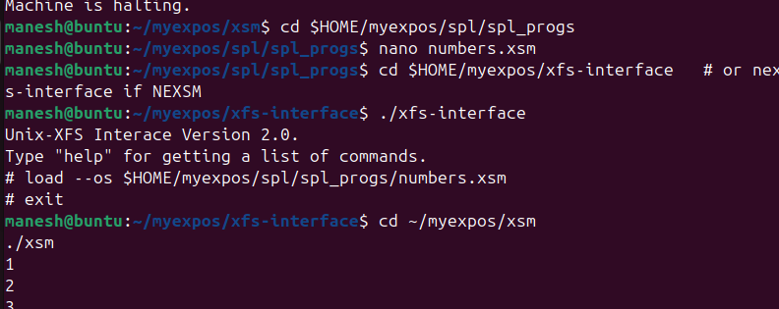

3. Run the machine

cd $HOME/myexpos/xsm  
./xsm

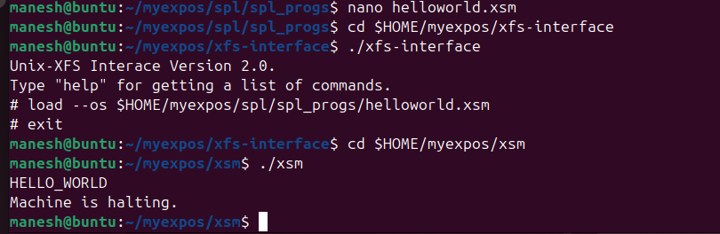

Assignment 1 - Write an assembly program to print numbers from 1 to 20 and

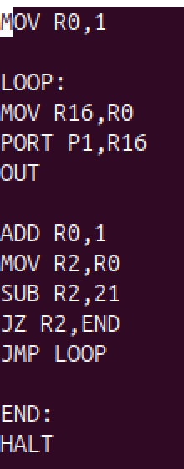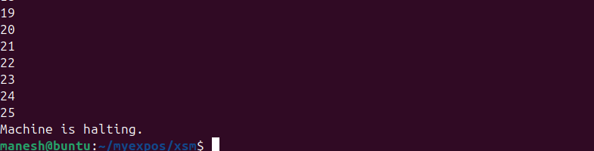

Stage – 4

1. Create the program to print odd numbers from 1 to 20 using SPL. (You can see more examples of SPL programs in $HOME/myexpos/spl/samples.)

alias counter R0;  
counter = 0;  
while(counter <= 20) do  
 if(counter%2 != 0) then  
 print counter;  
 endif;  
 counter = counter + 1;  
endwhile;

2.Save this file as $HOME/myexpos/spl/spl_progs/oddnos.spl. Compile this SPL program using

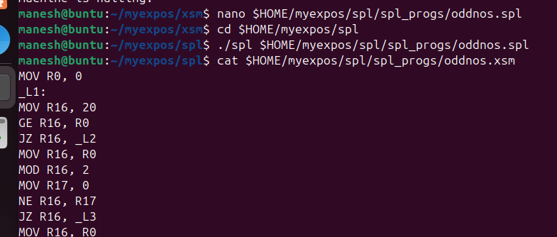

4.Load the file generated by the SPL compiler ($HOME/myexpos/spl/spl_progs/oddnos.xsm) as the OS startup code to disk.xfs using the XFS Interface.

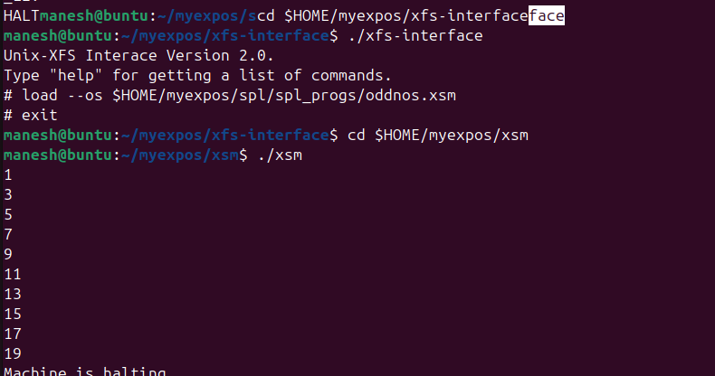

5.Run the machine.



Assginment –1

Write the spl program to print sum of squares of the first 20 natural numbers. Load it using xfs interface and run the in the machine.

1. Create assignment SPL program

cd $HOME/myexpos/spl/spl_progs

nano sumsq.spl

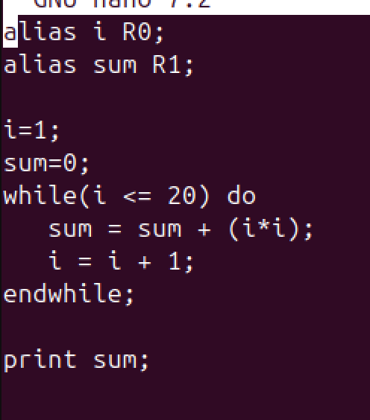

2.Complile the program

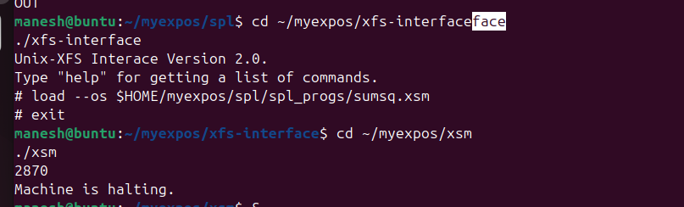

3. Load assignment program as OS Startup Code

4. Run the machine



Stage – 5

1.Write an SPL code to generate odd numbers from 1 to 10. Add a debug instruction in between :

alias counter R0;  
counter = 0;  
while(counter <= 10) do  
 if(counter%2 != 0) then  
 **breakpoint;**  
 endif;  
 counter = counter + 1;  
endwhile;

2.Compile the program using the SPL compiler.

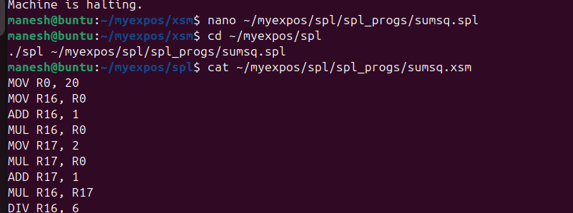

3.Load the compiled xsm code as OS startup code into the XSM disk using the XFS interface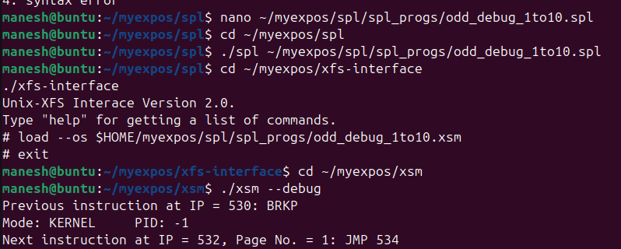

4. Run the machine in debug mode.  
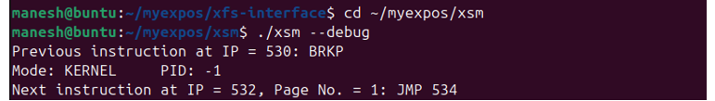

5. The Machine pauses after the execution of the first BRKP instruction.

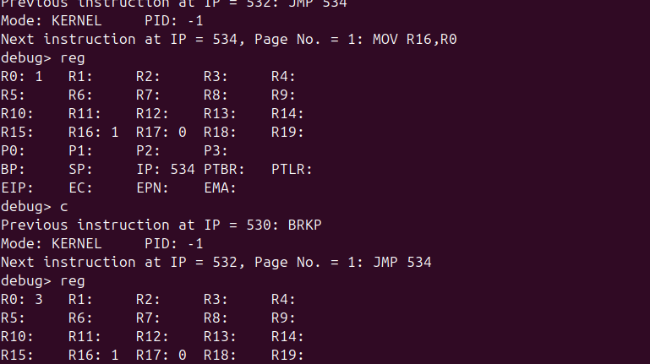

Stage 6

**Q1.** Suppose the machine is executing in unprivileged mode. Assume that the following are some of the register values:  
IP: 3000, PTBR: 29696, SP: 5000, PTLR: 10

[**a)** Which physical memory location will contain the physical page number of the page from which the machine will fetch the next instruction?](https://exposnitc.github.io/Roadmap.html#collapseq31)

29706.

[**b)** Suppose further that the memory location 29706 contains value 100. What will be the physical memory address from which the XSM machine will fetch the next instruction?](https://exposnitc.github.io/Roadmap.html#collapseq32)

51640.

[**c)** Suppose the instruction stored at memory address 51640 is JMP 3080, which all registers will be updated?](https://exposnitc.github.io/Roadmap.html#collapseq33)

IP will be updated to 3080.

[**d)** Suppose the instruction stored in memory address was MOV R0,[4096]. From which physical address will value be fetched and transferred to register R0? Assume that the value stored in memory address 29712 is 75.](https://exposnitc.github.io/Roadmap.html#collapseq34)

38400

[**e)** Suppose the instruction stored at memory address 51640 was MOV R0, [7000], what will happen?](https://exposnitc.github.io/Roadmap.html#collapseq35)

The machine will try to translate the logical address 7000 to the corresponding physical address. The logical page number 7000/512 = 13. However, since the PTLR value is 10 and the logical page number exceeds the value of PTLR, this is an illegal memory access. Consequently, the machine will generate an exception. You will learn about exceptions in later stages.

1. The following code illustrates the INIT program used in this stage. It computes squares of first 5 numbers. The value of Register R1 during each iteration will hold the result.

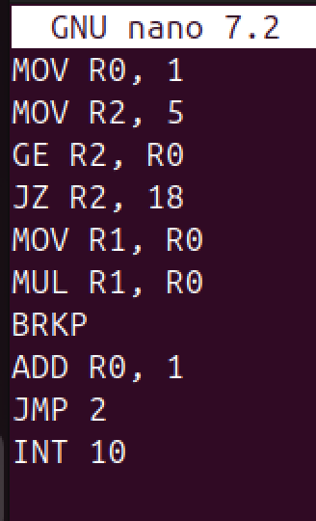

2. Load this file to the XSM disk as the INIT program using XFS interface.# load --init $HOME/myexpos/expl/expl_progs/squares.xsm

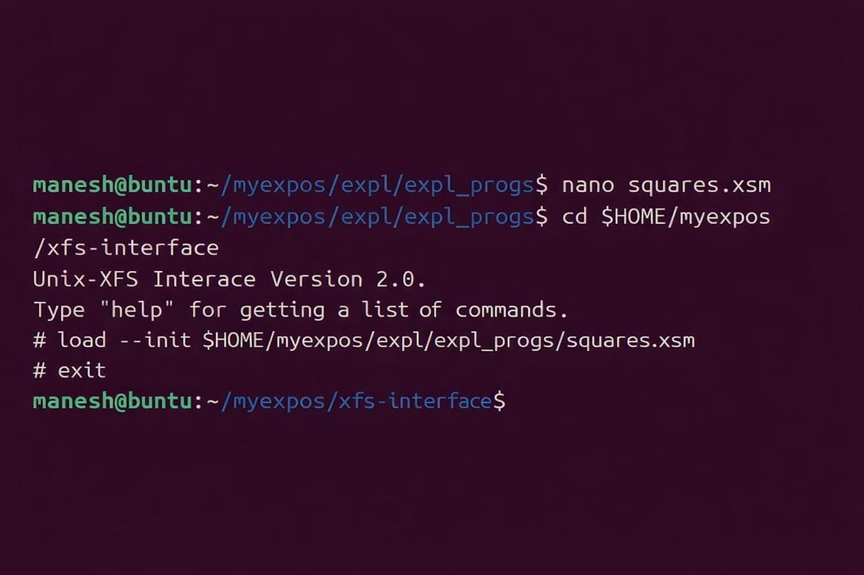

1. Create a file haltprog.spl with a single halt statement.halt;

2. Compile the program

3. Load the compiled code as INT 10 from the xfs-interfaceload

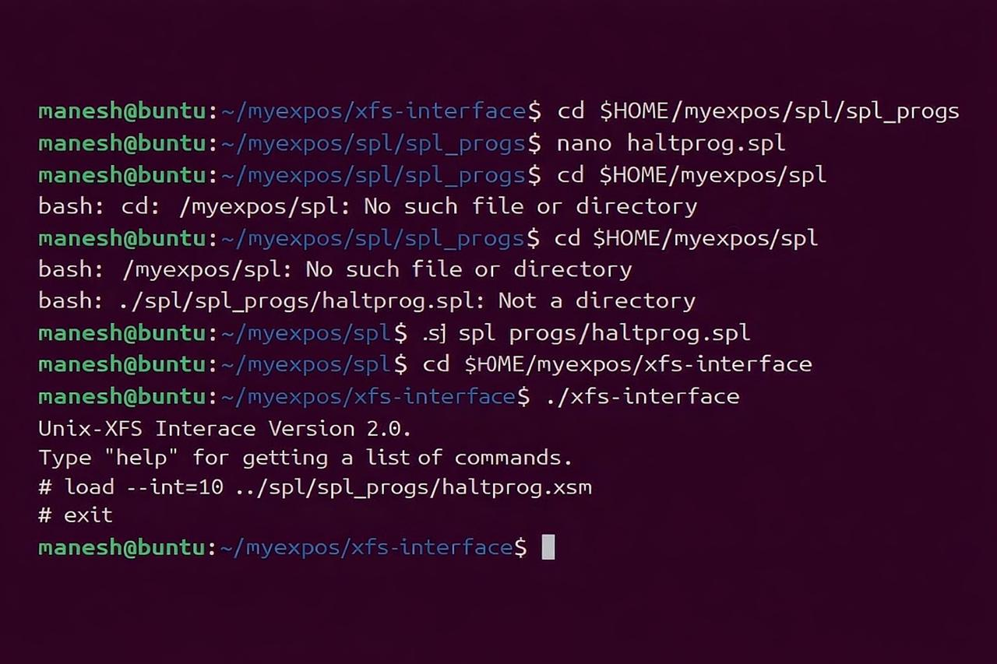

**Exception handler**

We also load the exception handler routine to memory. The machine may raise an exception if it encounters any unexpected events like illegal instruction, invalid address, page table entry for a logical page not set valid etc. Our default action is to halt machine execution in the case of an exception. In later stages you will learn to handle exceptions in a more elaborate way.

Load the haltprog.xsm used above as the exception handler using XFS-interface

load --exhandler ../spl/progs/haltprog.xsm

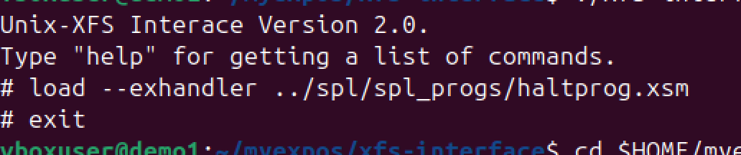

**OS Startup Code**

1. Load the INIT program from the disk to the memory. In the memory, init program is stored in pages 65-66. The blocks 7-8 from disk is to be loaded to the memory pages 65-66 by the OS startup Code. (See [Memory Organization and Disk Organization](https://exposnitc.github.io/os_implementation.html) ).  
     
   loadi(65,7);  
   loadi(66,8);Load the INT10 module from the disk to the memory.loadi(22,35);  
   loadi(23,36);Load the exception handler routine from the disk to the memory.loadi(2, 15);  
   loadi(3, 16);

Note the use of the loadi instruction for loading a disk block to a memory page. The loadi instruction will suspend the execution of the XSM machine till the disk to memory transfer is completed. XSM will execute the next instruction after the transfer is complete. (In later stages you will use the load instruction that can help to speed up execution).

1. [Page Table](https://exposnitc.github.io/os_design-files/process_table.html#per_page_table) for INIT must be set up for address translation scheme to work correctly. This is because INIT is a user process and all addresses generated are logical. Machine translates these logical addresses to physical addresses by looking up the page table for INIT.  
     
   The PTBR or Page Table Base Register stores the starting address of the page table of a process. We must set PTBR to the starting address of the page table of INIT. The [eXpOS memory organization](https://exposnitc.github.io/os_implementation.html) stipulates that the page tables are stored from memory address 29696. Here since we are running the first user program, we will use the first few entries of this memory region for setting up the page table for the INIT process. The [SPL constant](https://exposnitc.github.io/support_tools-files/constants.html) PAGE_TABLE_BASE holds the value 29696.  
     
   You need two pages for storing the INIT program code (loaded from disk blocks 7 and 8) and one additional page for stack (why?). Hence, PTLR is set to value 3.  
    PTBR = PAGE_TABLE_BASE;  
    PTLR = 3;
2. In the page table of INIT, set page numbers 65 and 66 for code and 76 for stack. (Pages 67 - 75 are reserved. See [Memory Organisation](https://exposnitc.github.io/os_implementation.html) .) Thus, the first word of each entry must be set to the corresponding physical page number (65 ,66 and 76). Set the second word ( [Auxiliary information](https://exposnitc.github.io/arch_spec-files/paging_hardware.html#aux_info) ) for pages 65 and 66 to "0100" and page 76 to "0110". This sets the code pages "read only" and stack "read/write". (why?)

[PTBR+0] = 65;  
[PTBR+1] = "0100";  
[PTBR+2] = 66;  
[PTBR+3] = "0100";  
[PTBR+4] = 76;  
[PTBR+5] = "0110";

Note: Here we have introduced a simple memory model with 2 page code and 1 page stack memory.  
The actual memory model which you will be using is different and will be explained in the later stages.

1. The OS Startup Code transfers control of execution to the user program using an IRET instruction. An IRET performs the following operations  
   1. The privilege mode is changed from KERNEL to USER mode.
   2. The instruction pointer is set to the value at the top of the user stack
   3. The value of SP is decremented by 1

The code of this program must execute from logical address 0. Hence IP or the instruction pointer needs to be set to 0 before the user program starts execution. As IP cannot be set explicitly, push 0, which is the value of starting IP to the top of the stack, and IRET instruction will implicitly set the IP to this value.

Since the OS Startup Code runs in KERNEL mode, physical address must be used to access the top of the stack. Stack of INIT process is allocated at physical page number 76. Its corresponding physical address is 76 * 512. The stack pointer must be set to point to this address so that IRET fetches the correct address.

[76*512] = 0;  
SP = 2*512;

1. Use the *ireturn* instruction to transfer control to user program. *ireturn* translates to IRET machine instruction
2. **Making Things Work**  
   Save the OS startup Code as $HOME/myexpos/spl/spl_progs/os_startup.spl. Compile this file using SPL compiler.

cd $HOME/myexpos/spl  
./spl $HOME/myexpos/spl/spl_progs/os_startup.spl

1. This will generate a file $HOME/myexpos/spl/spl_progs/os_startup.xsm. Load this file as the OS startup code to disk.xfs using the XFS Interface. Invoke the XFS interface and use the following command to load the OS Startup Code.

# load --os $HOME/myexpos/spl/spl_progs/os_startup.xsm  
# exit

1. Run the machine in debug mode. (We will disable the timer for now).

cd $HOME/myexpos/xsm/  
./xsm --debug --timer 0

1. View the contents of R1 at each step.



**Output**

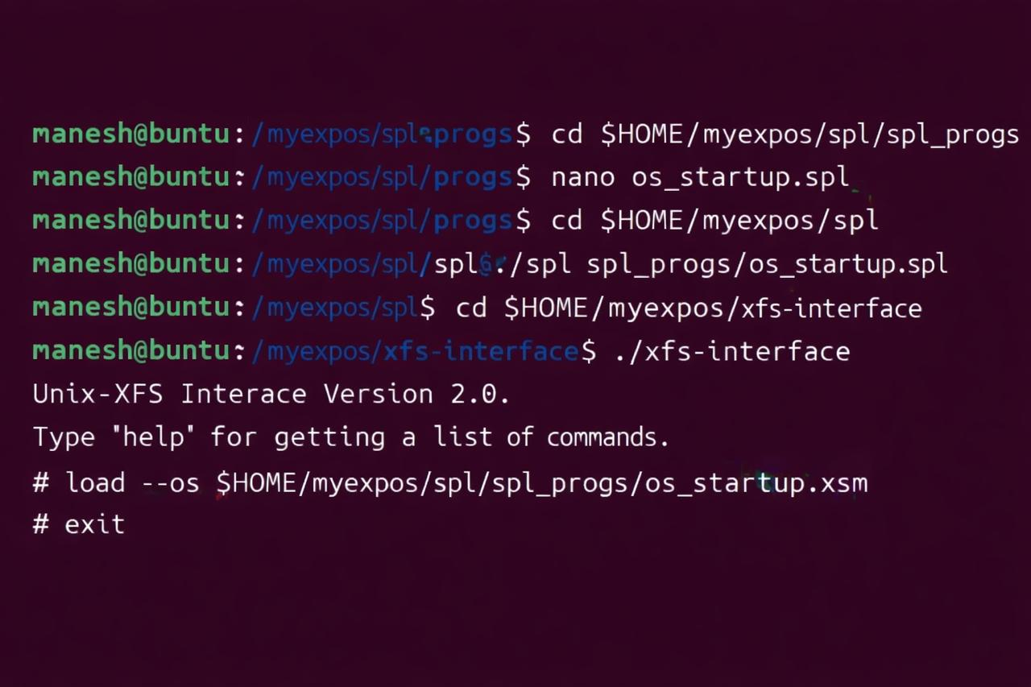

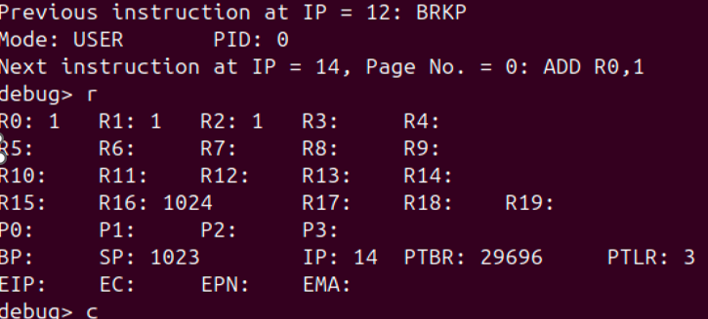

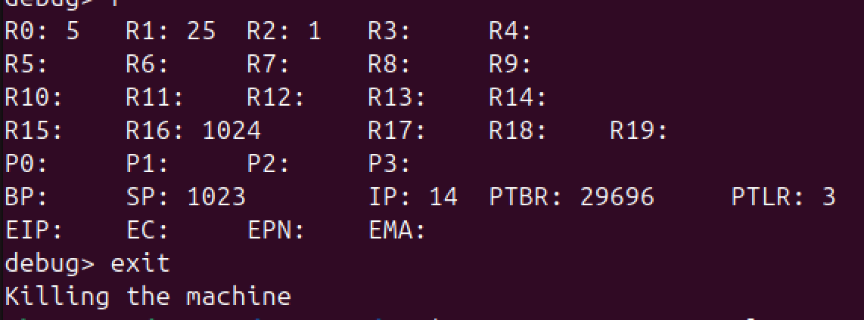

**ASSIGNMENT 1**

**Part - 1 Modify User Code**

**2048 MOV R0, 1**

**2050 MOV R2, 5**

**2052 GE R2, R0**

**2054 JZ R2, 2066**

**2056 MOV R1, R0**

**2058 MUL R1, R0**

**2060 BRKP**

**2062 ADD R0, 1**

**2064 JMP 2050**

**2066 INT 10**

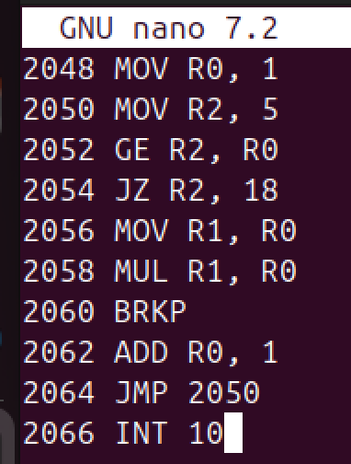

**Part - 2 Reload INIT into disk**

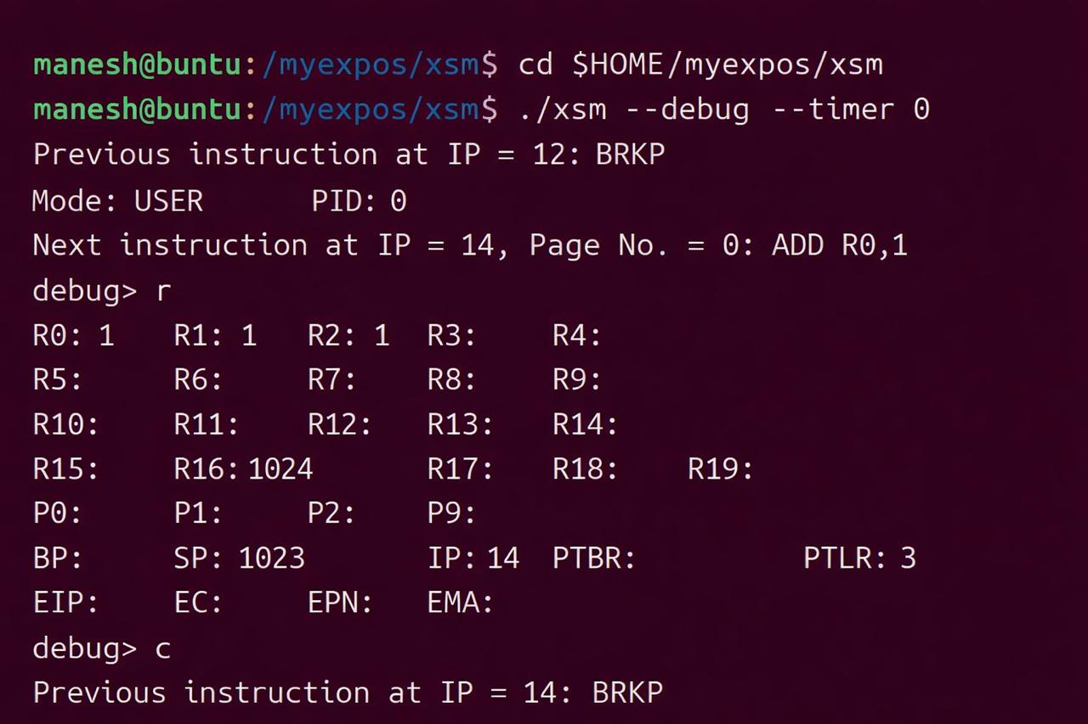

**Part 3 Modify OS Startup Code**

**loadi(65,7);**

**loadi(66,8);**

**loadi(22,35);**

**loadi(23,36);**

**loadi(2,15);**

**loadi(3,16);**

**PTBR = PAGE_TABLE_BASE;**

**PTLR = 9;**

**[PTBR+8] = 65;**

**[PTBR+9] = "0100";**

**[PTBR+10] = 66;**

**[PTBR+11] = "0100";**

**[PTBR+16] = 76;**

**[PTBR+17] = "0110";**

**[76*512] = 2048;**

**SP = 76*512;**

**ireturn;**

**Part 4 - Recompile Os Startup**

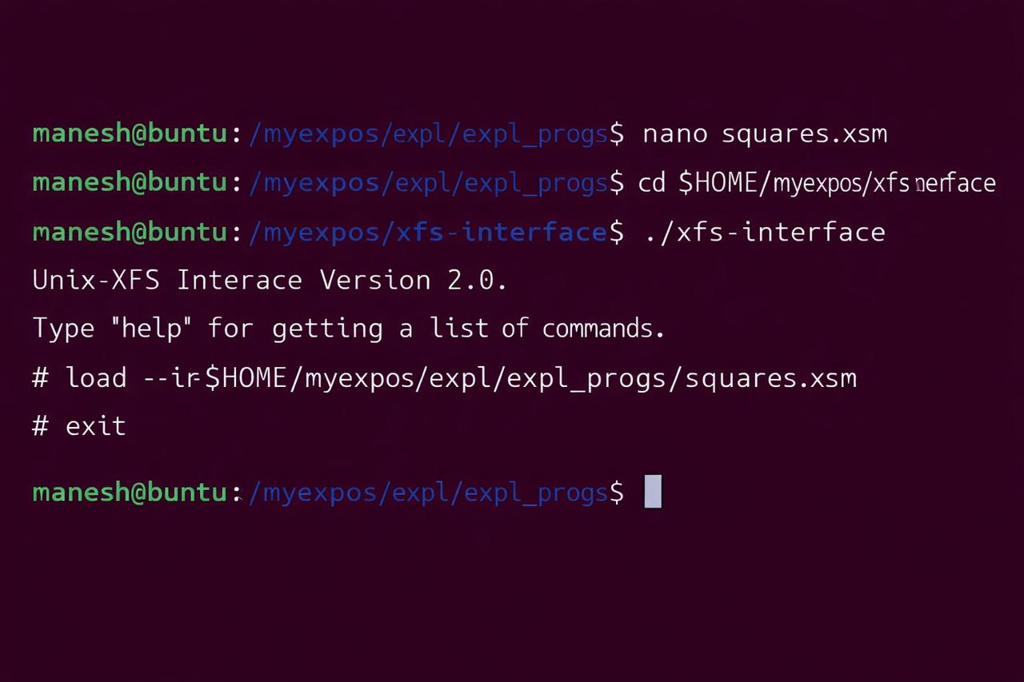

**Part 5 Run in Debug Again**



**STAGE – 7**

1.Load Library Code from disk to memory

loadi(63,13);  
loadi(64,14);

The eXpOS ABI stipulates that the code for a shared library must be loaded to disk blocks 13 and 14 of the disk. During OS startup, the OS is supposed to load this code into memory pages 63 and 64. This **library code must be attached to logical page 0 and logical page 1 of each process**. Thus, this code will be shared by every application program running on the operating system and is called the **common shared library** or simply the library.

The library provides a common code interface for all system calls. This means, to invoke a system call, the application can call the corresponding library function and the library will in turn invoke the system call and return values back to the application. The library also implements some functions like dynamic memory allocation and de-allocation from the heap area.

**The dynamic memory allocation functions of the library manage the heap memory of the application program. The ABI stipulates that each application must be provided 2 pages of memory for the heap. These two pages must be attached to logical pages 2 and 3 of the application.**

Note here that the library code is not part of the application's XEXE executable file. The library code is "attached" to the address space of the application when the application is loaded into memory for execution. Since the ABI stipulates the the library will be loaded to logical pages 0 and 1, the application "knows" the logical address of the library routines and will contain call to these routines, though the routines are not present in the application's code.

Thus, the OS must do the following to ensure correct run time linkage of library code to each application.

* 1. The library code must be pre-loaded to disk blocks 13 and 14 before OS startup. The library code can be found in the expl folder in eXpOs package. Load it into the XSM disk using the xfs-interface

1. load --library ../expl/library.lib
   1. During OS start-up, this code must be loaded to memory pages 63 and 64.
   2. When each application is loaded for execution, the logical pages 0 and 1 must be mapped to physical pages 63 and 64.
   3. Two physical pages must be allocated for the application's heap and attached to logical pages 2 and 3.

2.Modify the Page table entries according to ABI.  
The [SPL constant](http://exposnitc.github.io/support_tools-files/constants.html) PAGE_TABLE_BASE holds the value 29696. A total of 16 page tables can be stored starting from this address. Each page table will be 20 entries. For each user process, one page table will be allocated. Here since we are running the first user program, we will use the first few entries of this memory region for setting up the page table for the INIT process.  
  
As noted, the first disk block of the INIT program (block 7) must be loaded to logical page 4. Similarly, block 8 must be loaded to logical page 5. The ABI stipulates that two pages must be allocated for the stack at logical pages 8 and 9.  
  
The following code sets page table entries for logical page 4 and 5(for code area), logical page 8 and 9(for user stack), logical pages 2 and 3(for heap) and logical pages 0 and 1(for library). Since pages 0 to 75 are reserved for the use of the OS kernel, the first four free pages (76,77,78 and 79) will be allocated for stack and heap area. See [Memory Organisation.](http://exposnitc.github.io/os_implementation.html) Note that the code and library pages must be kept read only where as stack and heap must be read-write. (see [page table](http://exposnitc.github.io/arch_spec-files/paging_hardware.html) settings for details).//Library  
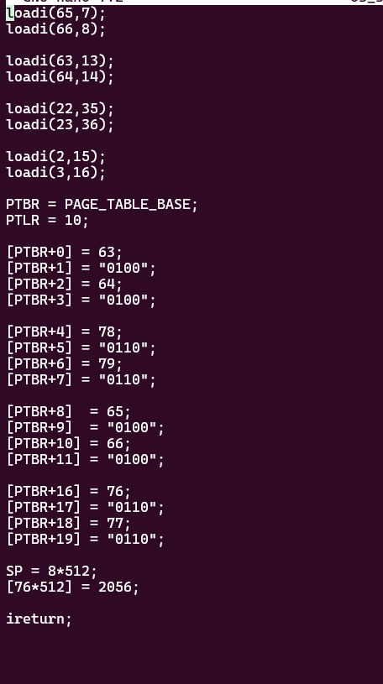

3. Since the total address space of a process is 10 pages, PTLR register must be set to value 10.

PTLR = 10;

4. The second entry of the header of an executable file will contain an entry point value. This is the address of the first instruction to be executed when the program is run. Hence, you must initialise IP to the second word in the header. Since the first code page is loaded into memory page 65, the address of the second word in header is calculated as (65 * 512) + 1. This value is stored to the top of the user stack. The machine on executing IRET instructions pops this value from the stack and sets IP to that value.

SP = 8*512;  
[76*512] = [65 * 512 + 1];

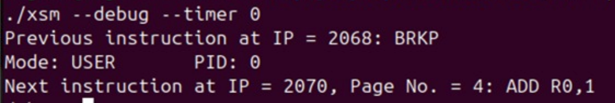

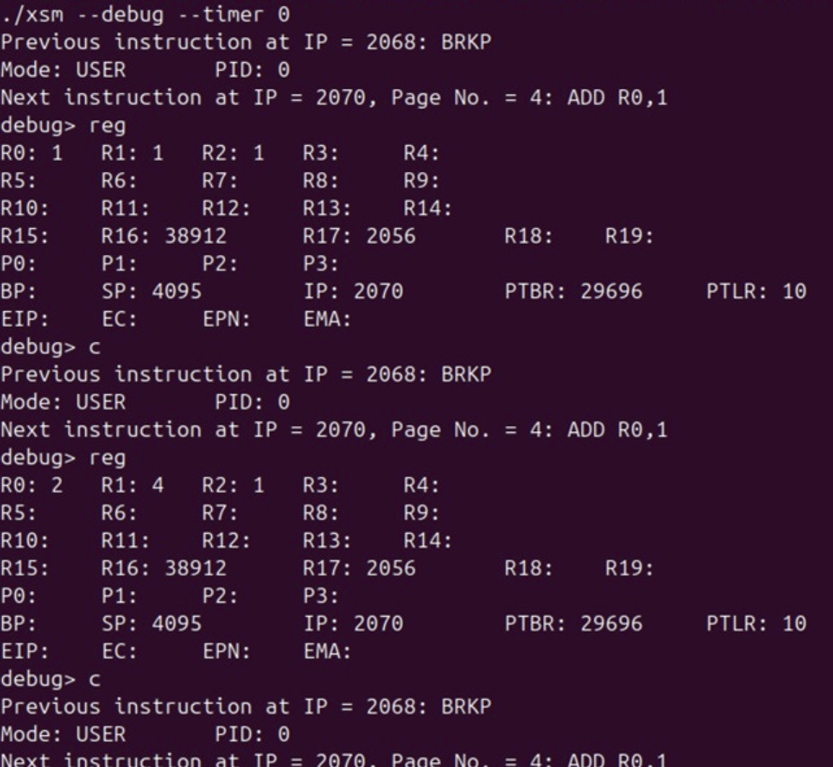

Assignment - 1

Change the user program to compute cubes of the first five numbers

1. **Modify INIT program**

MOV R1, R0

MUL R1, R0

MUL R1, R0

2. **Reload INIT program**

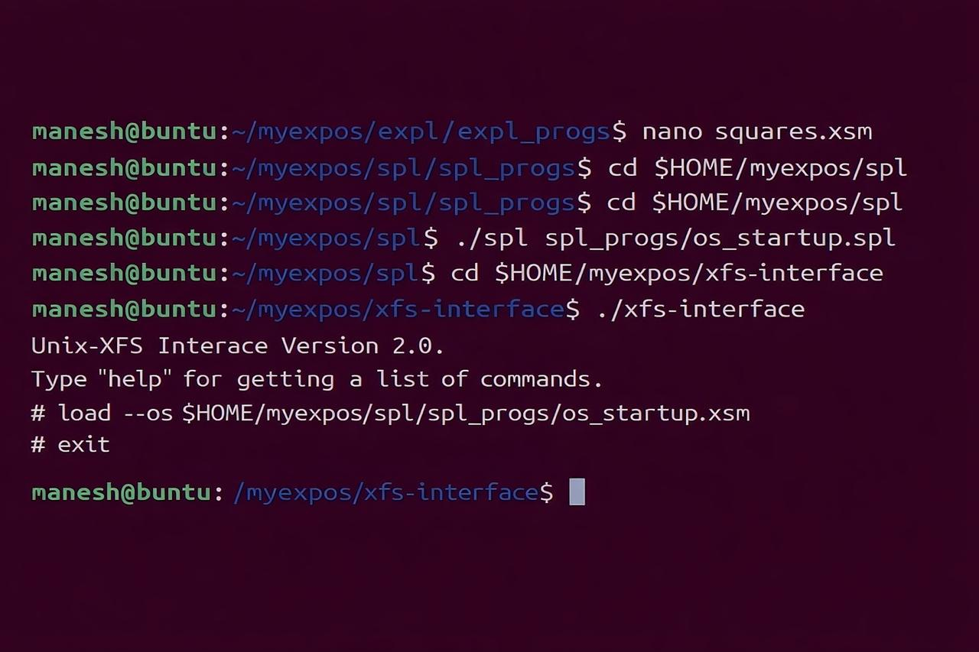

**3. Ru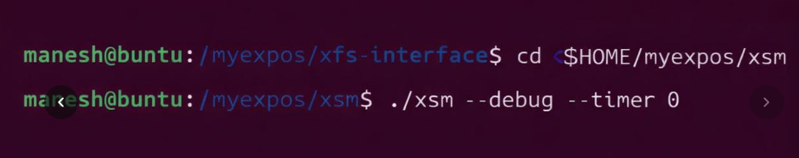n again**

**Output:**

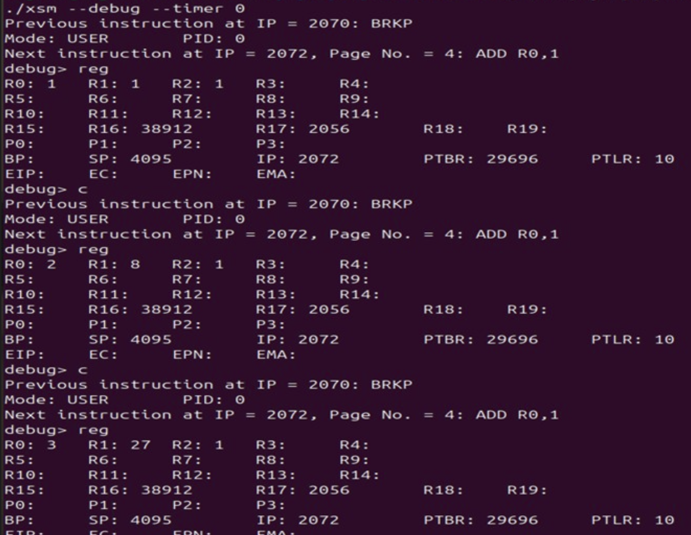

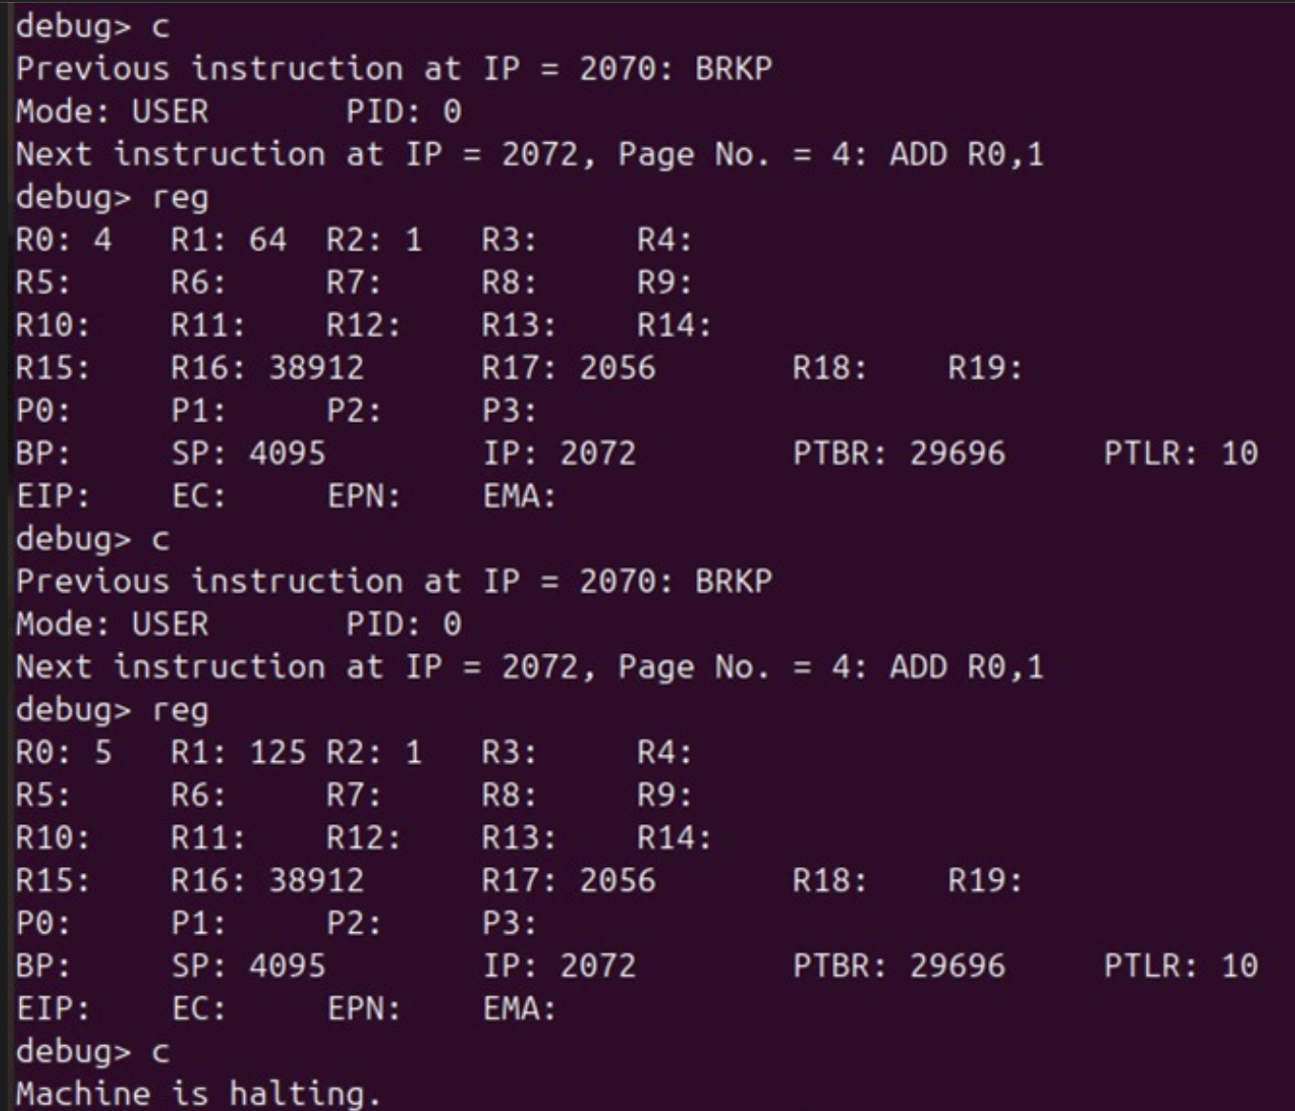

STAGE-8

1. **Save this file in your UNIX machine as $HOME/myexpos/spl/spl_progs/sample_timer.spl**

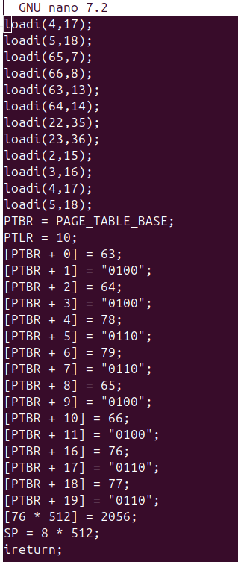

1. **Compile tgus program using the SPL compiler**
2. **Load the compiled XSM code as the time interrupt into XSM disk**

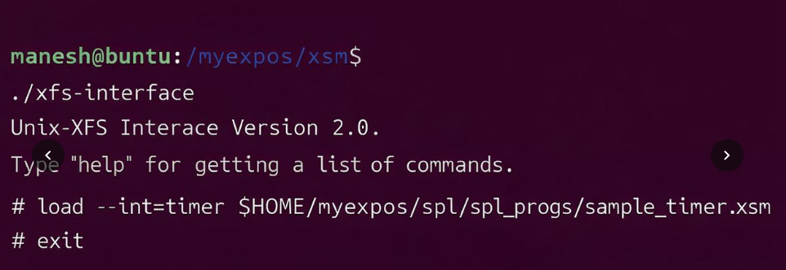

1. **Recompile and reload the OS Startup code**

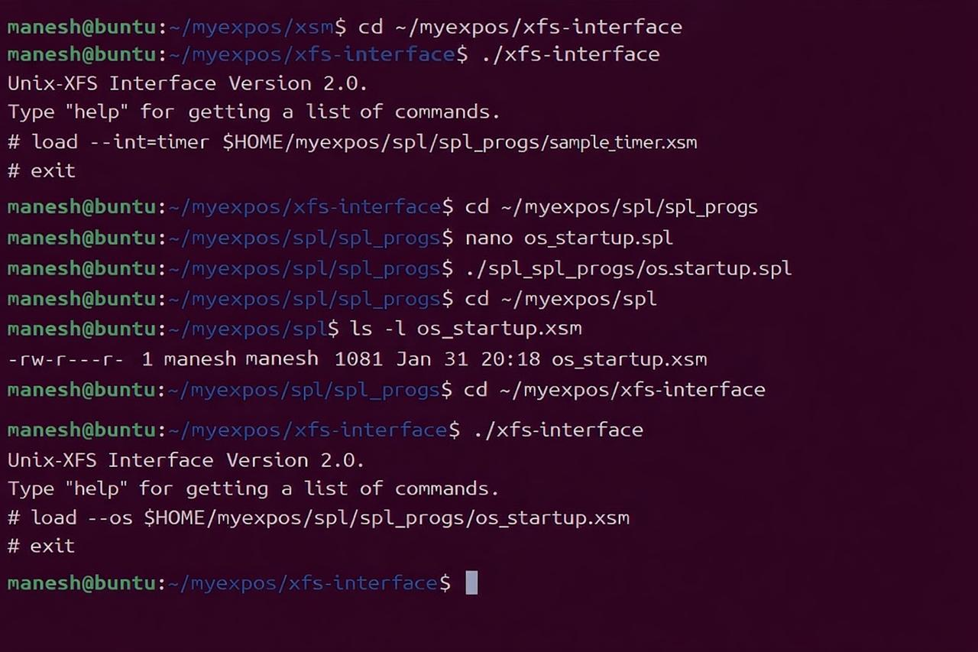

1. **Run the XSM machine with timer enabled**

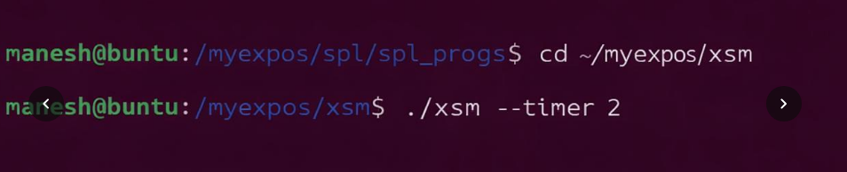

**OUTPUT**

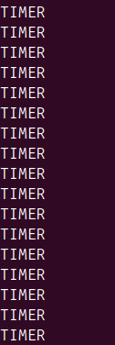

STAGE-9

1. **OS STARTUP CODE**
2. **Allocate user area**
3. **Set process ID (stored in process Table)**
4. **Update system status table**
5. **TIMER INTERRUPT**
6. **Save user stack pointer**
7. **Switch to kernel stack**
8. **Save user register**
9. **Print message**
10. **Restore user context**
11. **Return to user mode**

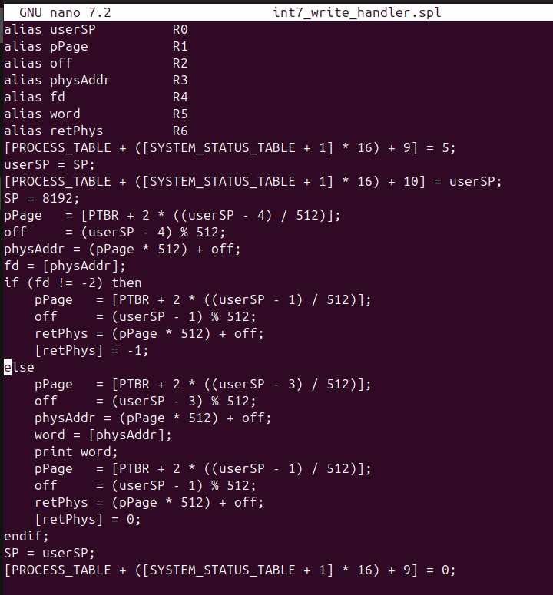

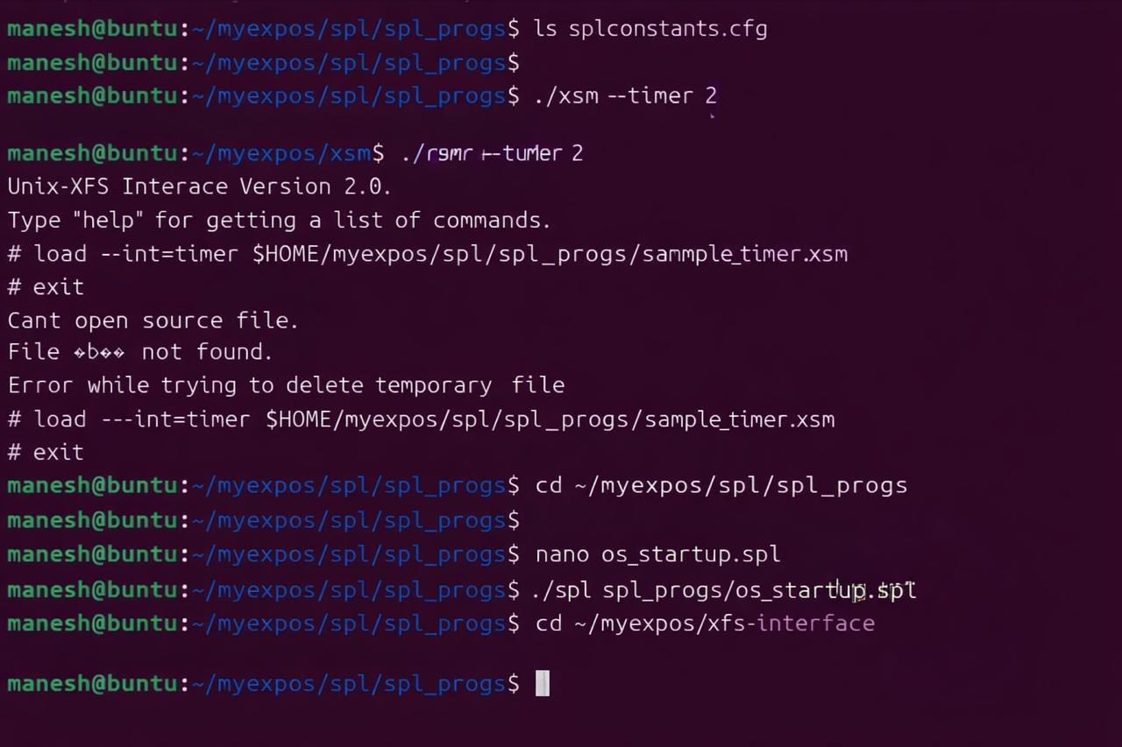

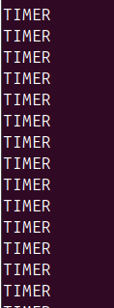

**ASSIGNMENT 1**

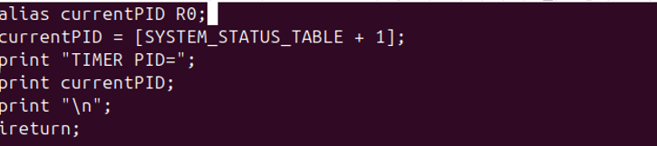

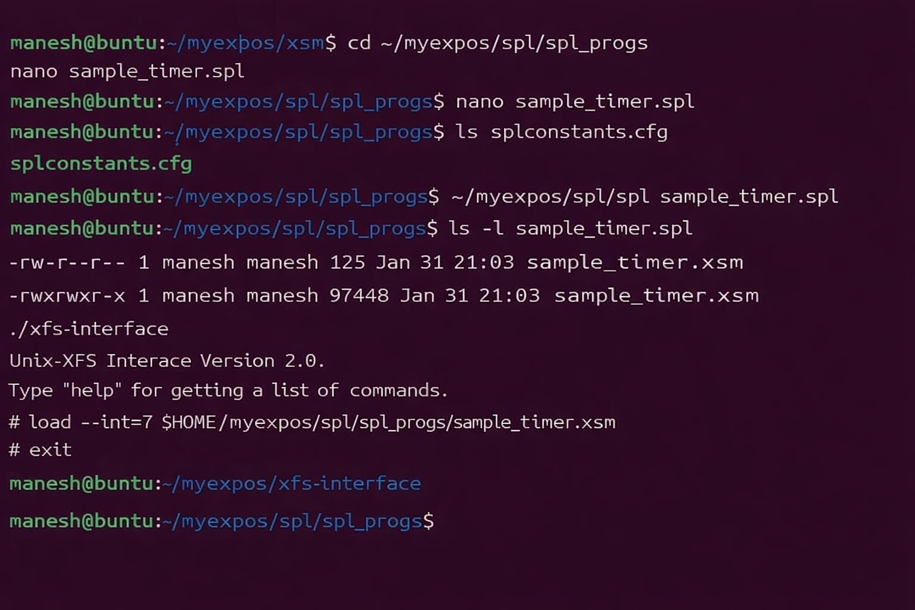

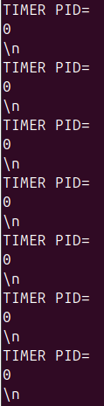

STAGE-10

